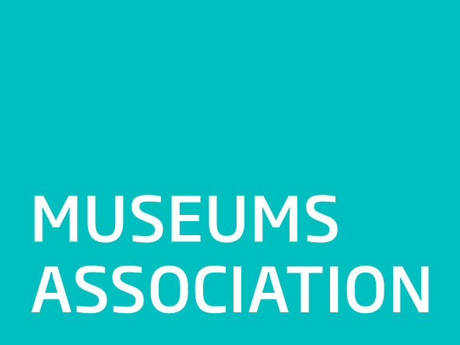

**DCMS White Paper on Culture: Additional Submission from the Museums Association**

*The Museums Association (MA), founded in 1889, is the largest museum sector membership organisation in the UK, representing the interests of over 8,000 museums and museum professionals.*

*We have made a joint submission to this consultation with other sector bodies and would like to use this opportunity to provide additional, supporting material to that submission.*

**Context**

Last year marked the 50th anniversary of the publication of Jennie Lee’s influential White Paper on the arts. The new Culture White Paper is a once-in-a-lifetime opportunity for government to set out its vision for culture. It is a chance for the Department for Culture, Media and Sport to provide a strategic and inspirational lead for the cultural sector that could have a lasting impact on museums and the public.

Culture is a devolved responsibility in the UK and museum strategies are in place in Scotland and Wales. DCMS could draw on these successful strategies that have substantial sector buy-in to create a far-reaching vision for museums in England.

Many museums are ambitious about their role in society and play a major role in their communities, enhancing health and wellbeing, creating better places to live and work, and inspiring people and ideas. Government can play a crucial role in encouraging and fostering the social and educational impact that museums deliver by working with communities and could help to address some of the main challenges that museums face in this area. Museums require leadership and support from government in order to deliver this agenda at a time when many museums face an extremely challenging funding climate.

**Civic Museums**

Civic museums face a number of major challenges in the next decade. There are around 700 civic museums in the UK. Many are housed in Victorian-era buildings in town and city-centres, caring for a wide variety of collections and providing an important focal point, sense of place and source of pride for local people, as well as drawing in visitors and tourists. Civic museums play a strong social and educational role in local communities, and are often the most easily accessible, often free, local cultural institutions in large population centres.

Many civic museums rely on public funding to deliver their services. The sharp decline in local authority discretionary funding from 2010 onwards has put increasing financial pressure on these museums.

These cuts have largely been absorbed through efficiency measures and increases in earned income. However, the MA has documented a number of recent closures of museums – a trend that is likely to continue as local authority funding declines further. In Lancashire, local authority museum funding will be cut by 92% from 1st April - and other local authorities are consulting on similar measures around the country. This further reduction in funding could leave whole areas of the country without museums.

The imbalance in funding outlined in several reports over the past few years and acknowledged by bodies such as Arts Council England also has an impact on regional museums and government intervention is needed to resolve this issue.

The MA supports the use of all the tools outlined in our joint submission in order to support civic museums, such as measures to encourage greater corporate giving and inclusion of culture in devolution agreements.

**The MA also believes that further action should be taken to support civic museums:**

Arts Council England currently provides support to museums across England under its Major Partner Museums programme and other investment including the Resilience Fund.

However, a strategy of investing in museums only in areas where local authorities are able to sustain investment risks leaving some areas without any museum provision and concentrating public funding on those areas that can afford cultural spending.

As a result, we believe that:

* **Government should take a lead on developing a strategic approach to museum funding working with bodies such as ACE and HLF to ensure an equitable distribution of spend throughout England**
* **Government should encourage a framework for national museum partnerships through funding agreements that require partnership working from all our national institutions and which target need in the regions**
* **Seed funding should be provided to encourage regional partnerships between groups of museums and between museums and other organisations**
* **A future ACE museum strategy should include a mechanism that ensures museum resilience across England with a focus on civic/regional museums**
* **ACE should have in place a mechanism to intervene where museums are under threat of closure in order to manage the possible transition to alternative management, the ethical management of the museum collection and continued cultural provision for the local area.**

**Museums and Social Impact**

Museums have a vital social role. They play a part in improving lives, creating better places for everyone to live and work and make a positive contribution to contemporary life. All museums, whatever their type or scale, can support positive social change. Enabling museums to play a full role at the heart of their communities will help deliver broader policy goals– improving social outcomes, enhancing the places that we live in, and building the UK’s cultural credentials globally.

The MA’s [Museums Change Lives](http://www.museumsassociation.org/museums-change-lives) campaign sets out how museums can improve their social impact. It also provides a range of examples of museums delivering this work: projects to reduce homelessness; to improve community cohesion and integration; to increase wellbeing amongst those with dementia and special needs; and to broaden horizons of young people.

However, at present, social impact is delivered in a patchwork manner by museums, and is often dependent on short-term project funding. It requires successful partnership working, expertise in outreach work, and committed leadership.

* **There is an opportunity for DCMS to support museums’ work in this area by launching a joint scheme including a challenge fund with relevant government departments (DfE, DoH, DCLG) to enhance the cultural sector’s delivery against specific social objectives.**

**A Diverse Workforce**

Museums face a challenge in recruiting and training a workforce that reflects the diversity of the communities that they serve. The long-term relevance of the museum sector to large portions of the public is at stake. Working in a museum – particularly in management, curatorial and learning roles – is widely viewed as a white, middle class career.

Attracting and training talent from diverse backgrounds should be a policy priority for museums. Government could take a lead in setting the tone in this area through funding agreements. Measures are needed to ensure that a more diverse workforce is recruited and trained and that culture change within organisations is fostered so that the existing workforce is aware of the benefits and necessity of diversity.

* **There is an opportunity for DCMS to support a package that would: encourage the uptake of apprenticeships and mechanisms for effective transition into ongoing employment; support practice that encourages diverse recruitment; and provide in-house and cross-organisation training opportunities to foster culture change. This could be enhanced through effective and diverse programming and activity in museums.**

**International work**

Museums in UK have a global reputation. Many countries look to the UK as a leader in museum practice as evidenced by the high numbers of international students on museum studies MA courses in the UK and the international demand for UK expertise in museum practice. There is also recognition that the UK sector plays a leading role in developing social impact work as demonstrated by the high demand for UK speakers at international conferences and events on the MA’s [Code of Ethics](http://www.museumsassociation.org/ethics/code-of-ethics) and its [Museums Change Lives](http://www.museumsassociation.org/museums-change-lives) campaign which help raise the profile of whole sector and develop links and prestige for UK museums and museum practice.

* **Government should play a coordinating role on international work with bodies such as UKTI and the British Council.**
* **Government should promote best practice in areas of audience development, social impact and community engagement at an international level.**

**Conclusion**

The White Paper presents an opportunity for government to be viewed as a champion of museums and culture and to set a tone that recognises the importance of collections and heritage to all our lives. The Museums Association urges DCMS and government to take this opportunity at this crucial time.