The Museums Association
A public consultation on museum disposal

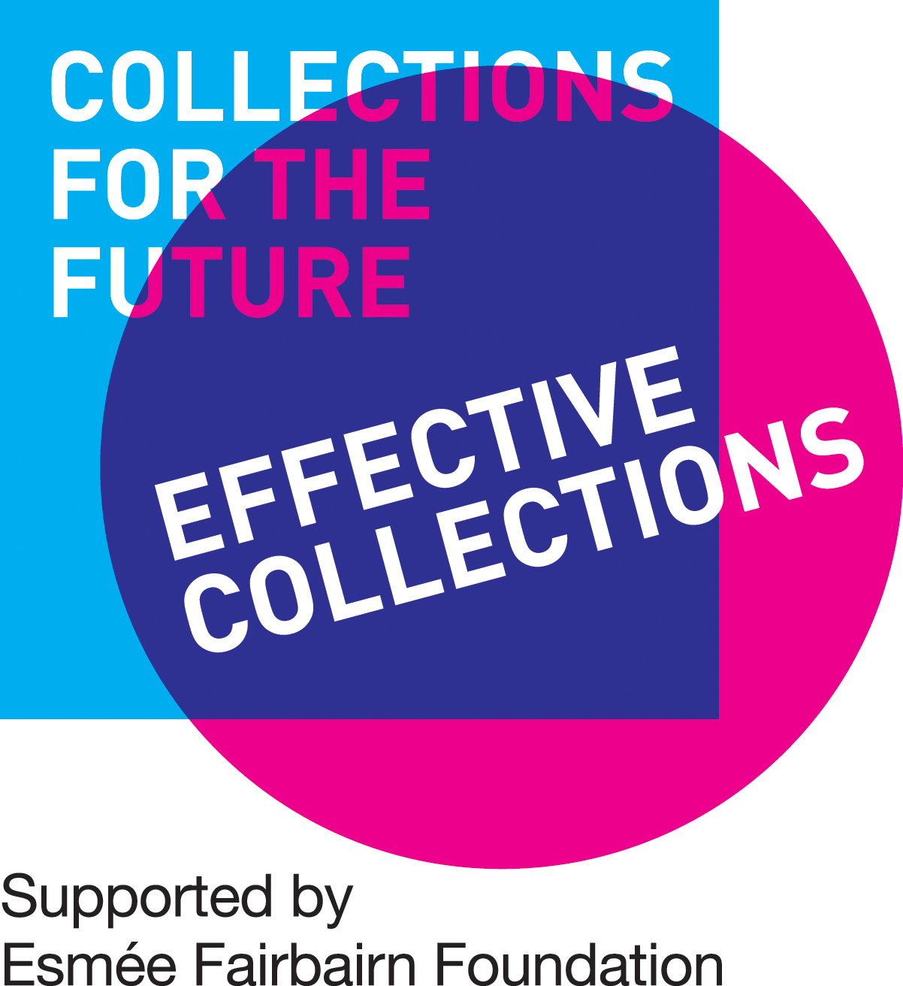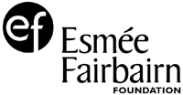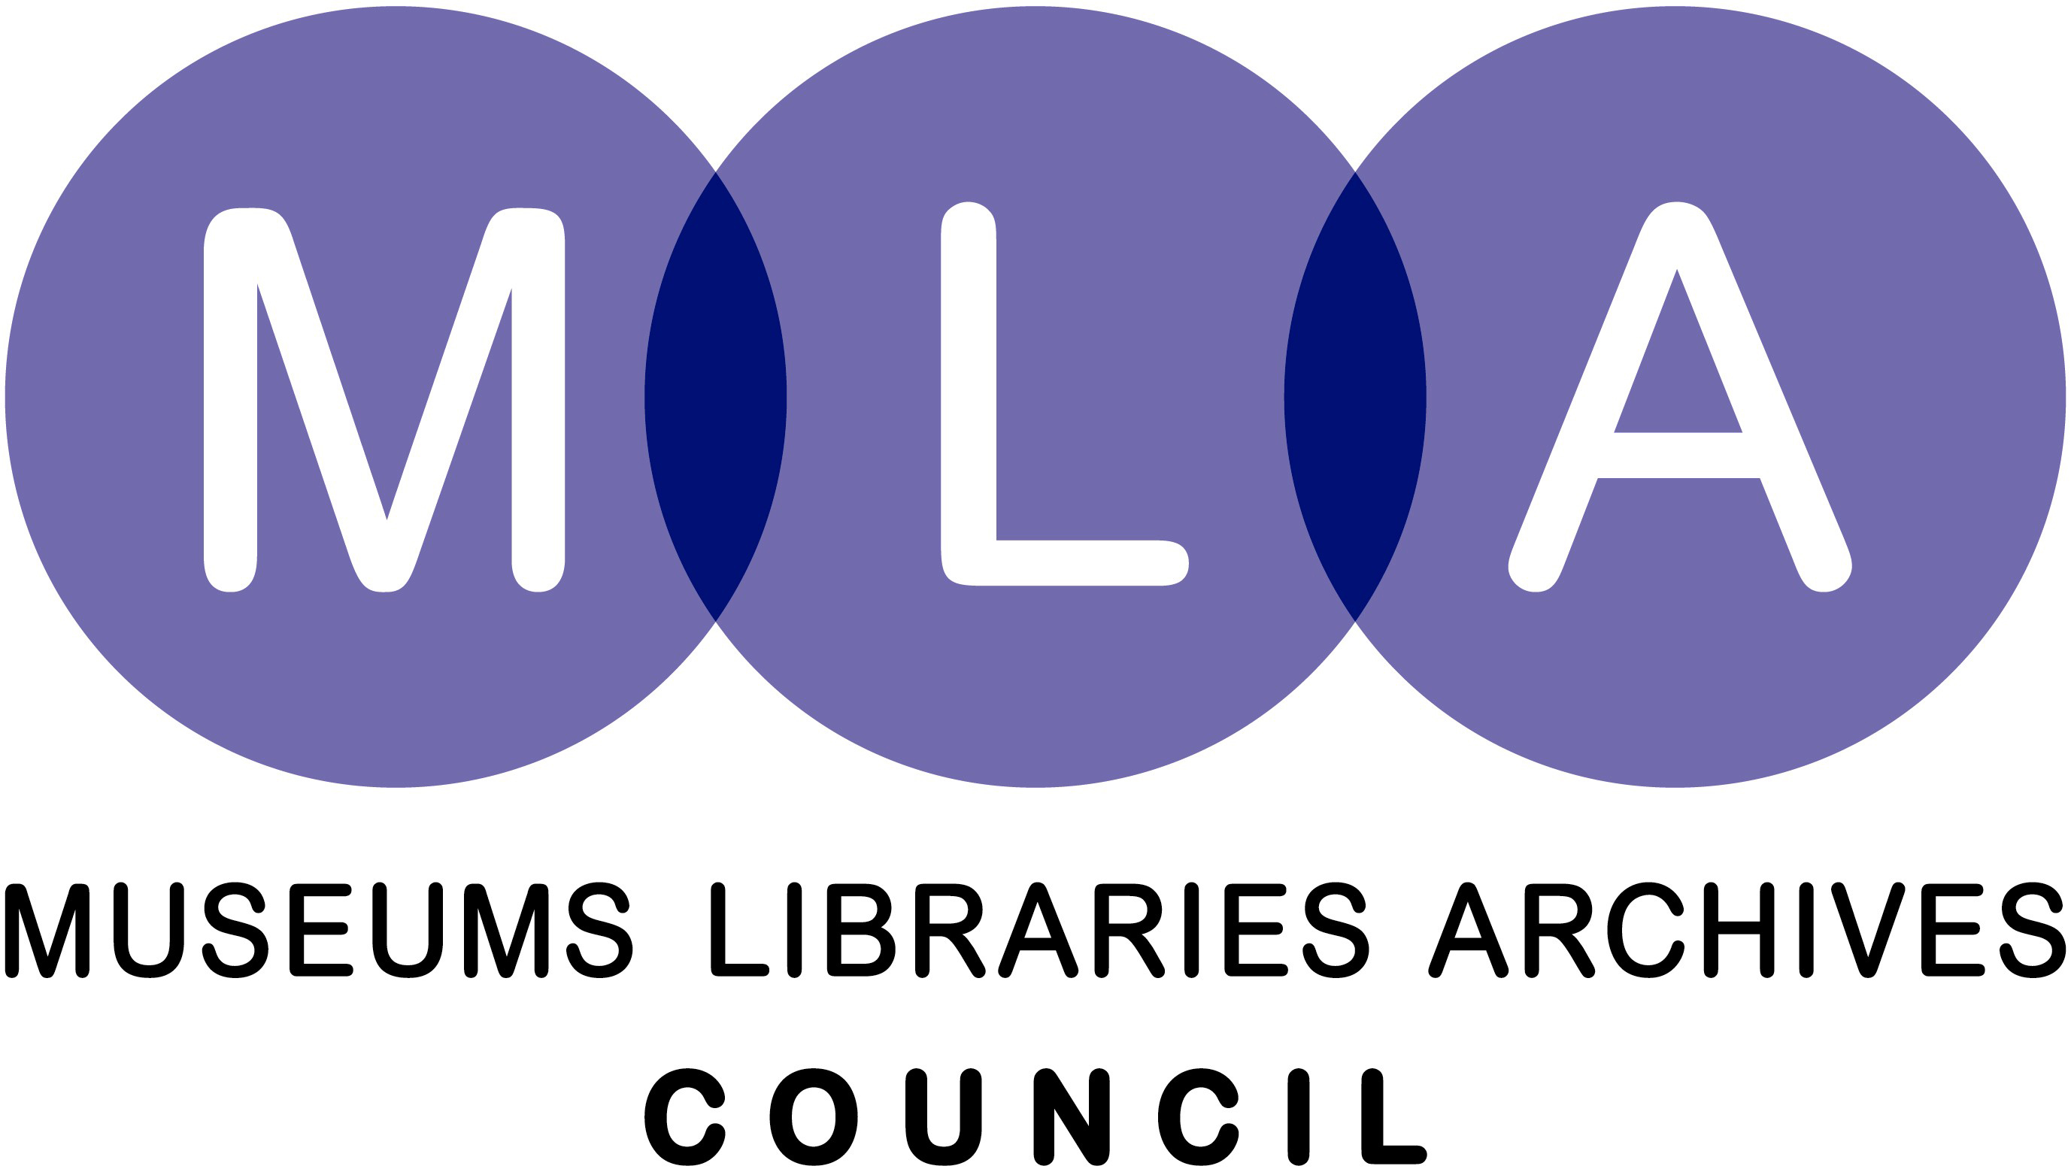

FreshMinds
229-231 High Holborn London WC1V 7DA
Tel: 020 7692 4300 Fax: 0870 46 01596
www.freshminds.co.uk
Table of contents

1. Executive Summary 3
Key findings 3
2. Introduction 5
The background to this project 5
Aims and Objectives 6
Methodology 6
3. Public perceptions and awareness of the role of museums 8
Summary 8
Public attitudes towards the role of museums 8
Public awareness of how museum collections are managed 10
4. Public perceptions of disposal 11
Summary 11
Public reaction to the word disposal 11
5. Public reaction to disposal 13
Summary 13
Disposal variables 16
6. Methods of communication between museums and the public 18
Summary 18
Reasons for communicating with the public 18
How museums should communicate with the public 18
7. Recommendations 20
Communication Strategy 20
When communication is necessary 20
Aspects to consider when developing communications processes 21

Executive Summary

This research was commissioned by the Museums Association in order to identify how museums can communicate collection management and disposal with the public. FreshMinds set out to accomplish this task by conducting research that firstly heightened an understanding of opinions within the sector and secondly observed the direct opinion of the public.

The first part of this research was a stakeholder workshop, organised by the Museums Association, in which members of the Museums Association, a culture journalist, museum curators and members of other relevant institutions debated the problems of communicating disposal with the public. The second part of the research was three focus groups to measure public awareness about museum collections and disposal. Two of the focus groups took place in London, one with older and the other with younger participants, and one in Newcastle. From this research FreshMinds could gain an understanding and provide recommendations about how, what and when museums should communicate with the public in matters of disposal.

From all three focus groups we discovered the following points regarding the public’s perceptions of museums and disposal. These were the key findings that FreshMinds analysed to provide the Museums Association with recommendations for a communication strategy.

This research has been supported by Effective Collections, MLA and the Museums Association.

Key findings

The role of museums was perceived to be for research and education, to demonstrate artefacts in an interactive way, and providing insight into specialist subjects that are otherwise inaccessible to the public. Participants commented that museums ‘make you think about new things’, ‘experience different cultures’ and ‘increase knowledge about a specialist interest’. Collections Management had typically not been considered by focus group participants. However, once prompted, participants understood the need for museums to manage collections, identify storage needs and transfer, loan, sale and destroy items as part of active management.

Disposal Perceptions were limited amongst all focus group participants. The word ‘disposal’ tends to conjure negative connotations, including suspicion, shock and scepticism. When questioned regarding its meaning, disposal tended to be associated with destruction and sale. This could be because collections management does not appear to be written about frequently in the media. Participants could recall very few stories or news items that involved collections management. Unless a headline was particularly provoking, participants would tend not to notice such stories.

Reactions to disposal remained negative until the context was put in place. All groups reacted negatively to the initial headlines, e.g. ‘‘a high profile national museum sells a series of paintings by a famous artist to buy a more fashionable item’. Reactions tended to be stronger amongst the older age group in London and the group in Newcastle – where words such as ‘shock’ or ‘disappointment’ were used on a regular basis. This proves that the main stakeholders of museums amongst the general public are those with an attachment to local museums or those concerned about the heritage of the country.

When participants were presented with more information about the context of the disposal, reactions tended to soften, proving that the context and the individual situation of the museum is an important driver of public opinion. FreshMinds analysed reactions to different disposal scenarios in the focus groups and established some key drivers of public reaction to disposal stories. These were cost, destination, origin of item, donation status and type of disposal.

FreshMinds used the focus groups to draw recommendations for the Museums Association to manage reactions to disposal in the public sphere. Clarifying Disposal is necessary to suppress negative assumptions. Misunderstanding of the word and process of disposal is fundamental in creating public negativity. Museums can begin to solve communication problems by increasing transparency about what disposal means and how the process works.

Explaining the Context and Highlighting the Benefits of disposal will decrease public negativity. Focus group participants reacted cynically to the concept of museum disposal – particularly when this was in a ‘headline’ or limited form. However, once presented with a context and explanation of museum decision-making process, reactions softened, and a sense of understanding and sympathy emerged. This suggests that public reaction can be managed through the provision of context, a decision-making process and a contact for further information. When presented with this information, members of the public are unlikely to respond with hostility. All disposal techniques are acceptable to focus group participants, provided that sufficient information and explanation is given. The public reaction can also be managed by providing a ‘rationale’ for disposal. Reaction can be further managed by highlighting the potential benefits of disposal, be this displaying a new collection, allowing a collection to be housed in a more appropriate environment or increasing education opportunities by transferring collections to a university or research environment.

Consultation received a mixed reaction amongst the public. When presented with the idea of ‘having a say’ in collections management – before and during the disposal process, opinions were divided. Younger participants tended to react with scepticism, and were less interested in being part of a decision-making process. However, other groups tended to see a value in this process, with this factor often swaying opinion about the actions of the museum. This was particularly evident with regard to collection disposal in local museums. Not all members of the public are interested in being involved in museum decision-making regarding disposal. However, those members of the public most likely to react strongly (older members of the public, and those involved in local culture) expressed interest in the consultation process, and would react positively to the opportunity to learn more about the challenges of collections management. Consultation processes that aim to inform the public about collections management and respond to questions and suggestions are likely to impact positively upon the way museums are viewed, and the way in which members of the public react to disposal.

The focus groups revealed some helpful insight about when and how museums should communicate with the public. Focus group participants knew little about museums’ decision-making processes and had little understanding about the challenges they face. Exploring communication techniques outside the traditional press were highlighted, including website information, direct advertising to raise their profile with the public, and a museums awareness week to stimulate debate and increase understanding. Members of the public will understand the challenges facing museums when informed, and are unlikely to react negatively when provided with a context and rationale for disposal. Suggested communication techniques included appropriate media coverage, leaflet drops and the provision of a contact point for further queries.

Introduction

The background to this project

“Museums and galleries tell the story of this nation, its people and the whole of humanity. It is impossible to imagine how else that story could be told, or what the landscape of Britain would look like without them.”

As Tessa Jowell concisely articulates, the museums and galleries (M&G) sector has a vital part to play in 21st Century Britain. The sector has certainly moved on from the days of museums being perceived as elitist or highbrow to one that has a definite and wide-ranging contribution to make to society. The public benefit of museum collections is wide-ranging and difficult to quantify – after all, museums provide a ‘tangible link between past, present and future’. They have a part to play in our definitions of citizenship and identity, allow us to celebrate change, diversity and difference and help us define our own social values.

It is perhaps this broad and complex mixture of expectations levied on museums that has led to much of the current debate around the future of collections. With around 200 million artefacts being held in public and private museums around the UK, the MA has recognised the need to discuss how public access to collections can be improved, how collections can be preserved and enhanced and consequently, how the disposal process should be dealt with. Reports such as the MA’s Inquiry ‘Collections for the Future’ and NMDC’s ‘Too much stuff?’ have begun to examine some of the complex issues relating to disposal. The MA is currently conducting a sector-wide consultation about attitudes towards disposal and is looking to build on this, and the existing research in the area, with this project which will examine the public’s understanding and attitude towards disposal.

The notion of disposal raises some complex and potentially conflicting issues. On the one-hand, the MA, in its capacity of ‘keeper of the code’ and ‘ethical guardian’ to the museums sector, has a social obligation to ‘safeguard the long-term public interest in the collections’. The Code of Ethics’ first commitment is to ensure that museums ‘never relinquish the trust invested in them, without public consent’. The undercurrent running through the MA’s ethical guidelines is that there should be a ‘strong presumption against disposal’. It should only occur as a last resort, if all other avenues have been exhausted, even though many existing collections may remain unused and inaccessible to the public. However, as Jane Glaister notes in her essay in ‘Collections for the Future’, many museums’ staff ‘find the notion that collections can be underused problematic. It conflicts with their sense that museums have a duty to preserve material for future generations’. MA recognises that it is part of a museum’s professional and ethical responsibility to face up to disposal. A balance must be achieved between the need to preserve collections for the future with the fact that museums can not keep spending public resources caring for objects that will never be enjoyed or used. This is the crux of the issue and a key reason for MA to be pursuing this public consultation.

Existing evidence about the public’s attitude and understanding of disposal is anecdotal and often focuses on the public outcry which sometimes ensues following media coverage of controversial disposal practices (e.g. Bury’s decision to sell a Lowry painting displayed in the town hall (2006) and Keele University’s sales of some rare academic books (1999), both of which contravene the code which forbids financially motivated disposal). However, even when museums go through the correct procedures to dispose of items, public outcry still sometimes results if museums do not successfully and transparently communicate the reasons why the items are being disposed of. Disposal, after all, has the potential to evoke an emotional response from communities and descendants of the donors to the museums if they do not understand the context of the disposal. The MA is worried that the public’s misconceptions and lack of understanding of disposal might impact on people’s decisions to donate to collections in the future.

Aims and Objectives

This project is designed to provide the MA with:

- An insight into the public’s current understanding of and attitudes towards museum disposal and practical guidance as to how gaps in understanding could be improved.

- An evidence base which the MA will be able to feed into the development of new ethical guidelines that will empower museums to begin to view disposal as integral to maintaining future collections.

This research project focused on exploring the public’s level of understanding and attitude towards current disposal practices in the UK museums’ sector.

Methodology

The project consisted of two main elements:

Stakeholder Workshop
To develop a thorough understanding of current collections management techniques and frame a topic guide for focus group discussions, FreshMinds facilitated a two-hour workshop with the Museums Association and relevant stakeholders such as the MLA, DCMS and NMDC. This workshop identified key themes and issues to be tested in later stages of research.

Focus Groups
Three focus groups with members of the public allowed FreshMinds to develop a qualitative overview picture of understanding of, and attitudes towards museum disposal. The groups were used to explore public perceptions of the role of museums, interest and understanding of collections management, and need and preference for communication between museums and the public on matters of disposal. Focus groups are invaluable in informing communications strategies, assessing interest and gauging reactions to various disposal techniques and scenarios.

To enhance the value of the groups FreshMinds and the Museums Association were eager that one of the groups took place outside of London. Newcastle was chosen for the last focus group because it offered an interesting regional comparison to London.

The groups were composed of the following participants:

- London focus group (age 25-35), with a cross section of socio-economic, and ethnic backgrounds
- London focus group (age 35+), with a cross section of socio-economic, and ethnic backgrounds
- Newcastle focus group (cross section of ages and backgrounds)

Stringent screening of participants for the discussion groups was of crucial importance. On the one hand, participants were required to have a basic level of interest in museums so that they were able to express opinion on disposal processes. On the other hand, this project was a consultation with the general public rather than stakeholders in the sector, so it was important that participants did not already have a vested interest in disposal or sector policy.

The focus groups were conducted in the following format:

- Testing existing knowledge – initially we sought to examine exactly what members of the public currently know about disposal – e.g. What do they understand by the term ‘disposal’ in the context of museums? Why do they think it is/ is not necessary? Under what circumstances does it occur? Can they identify any examples of disposal from the media?
- Testing attitudes towards disposal – this fed into a discussion to draw out how they currently view ‘museum disposal’ (based on their current understanding of the process, be it right or wrong) - How do they view disposal? Under which circumstances is it acceptable? How does it change their views of museums (if at all)? Do their views about disposal impact their decision to donate to collections?
- Identifying knowledge gaps/ misunderstandings – this enabled us to identify where gaps currently exist in the public’s knowledge and understanding of disposal.
- Exploring scenarios and re-testing attitudes – having identified the gaps in understanding, we were then able to provide the groups with new information to fill in knowledge gaps. We talked through three different scenarios (previously agreed with the MA) to explore different situations. For example, do attitudes change if ‘disposal’ occurs from an un-viewable collection in one museum to a school where children will be able to learn about artefacts firsthand? Is disposal acceptable as a last resort if all other avenues have been exhausted? Does the final destination of an artefact affect how disposal is viewed (e.g. a private collection in the UK vs. a public collection in the USA vs. a school vs. destruction vs. a sale funds for the museum vs a sale generating private funds)? Do attitudes towards disposal change if the public is made aware that public funds are being spent on preserving collections which are not being used? Discussion of different scenarios allowed us to gauge whether attitudes change when misconceptions about disposal are corrected or when new information is provided. Exploring different scenarios has aided the MA’s understanding of where attention needs to be focused and how the public’s attitudes may be situation-specific. This is useful to feed into future guidelines about how to communicate disposal to the media and general public in future.
- Ideas for improvement – finally we explored ideas around the best ways to communicate disposal to the public and methods for increasing the level of understanding of the issues around disposal.

Public perceptions and awareness of the role of museums

Summary

To gain an insight into public attitudes towards disposal and communication strategies it is necessary to understand the public’s perception of the role of museums. The curators present at the stakeholder workshop suggested that communication with the public was stunted by the public’s misunderstanding of ‘the whole system and administration of museums’. The workshop also revealed that the purposes, collections and management of local and national museums can vary considerably. Consequently public perceptions of local and national museums may differ and is a theme worthy of examination.

Understanding the purpose and processes of a museum is fundamental to understanding why disposal is a necessary reality. To understand public perceptions about the role of museums FreshMinds commenced each focus group with a discussion regarding the nature of museums, reasons for visiting, and any perceived differences between local and national museums.

Key Findings:
- Museums fulfil an educational role, ‘preserving history’ and culture and displaying collections in the most suitable and effective manner.
- National and local museums were seen as fulfilling different roles. The former were seen as housing high value collections of national significance – often a tourist draw. The latter were perceived as being embedded in the local community, perhaps focusing upon more specialised collections.
- Once prompted, participants understood the need for museums to manage collections, and identified storage, transfer, loan, sale and destruction as key methods of active collections management.
- All participants, when questioned, noted that final decisions regarding collection management should be made by museums alone. ‘I want to know that someone who has profound knowledge of the museum and specialist knowledge controls the collections rather than it just being members of the public’.

Public attitudes towards the role of museums

Reasons for visiting museums
Focus group participants noted the key roles of a museum as a research and educational facility, as demonstrating artefacts in the most appropriate and interactive way, and providing insight into specialist subjects that would otherwise be inaccessible to the public. Museums are seen to ‘make you think about new things’, ‘experience different cultures’ and ‘increase knowledge about a specialist interest’.

In London, museums were also viewed as offering ‘space’ to contemplate and reflect, and in Newcastle they were perceived to be a family activity.

It is interesting to note the perceived differences in museum role, depending upon local or national status. These are presented in Figure 1: Opinions about what the purpose of national and local museums are.

Figure 1: Opinions about what the purpose of national and local museums are

Focus Group | National Museums | Local Museums
London younger participants | - Older collections  - More geared towards tourists  - More of a day out  - Wider range of collections  - They have more space and funds to change exhibitions | - More specific audience  - More specialist collections  - Limited space and funding  - Preserving local heritage  - Don’t change their collections as often because they have a more definite function
London older participants | - School project work is a greater priority  - Displaying examples of national heritage  - Would expect it to be busier  - Have more rotating exhibitions  - Can afford to have more specialist items or have temporary specialist exhibitions | - Items that are found locally  - Items that have significance for local community  - Smaller collections  - Embedded within the community  - Willing to pay because they will have fewer people coming through the doors
Newcastle | - Charge more money  - More geared towards tourists  - More publicised  - House items of national interest  - More ‘snooty’  - More specific and specialised collections  - Assumption that visitors have more knowledge before they attend | - More specific area of interest  - Portraying the local culture  - More interactive  - Smaller scale so more hands on  - Change exhibitions more often  - Worth visiting more often  - Attended only by local people  - Poorly publicised

Source: FreshMinds

Purpose of museums
Expectations and assumptions regarding the role of a museum vary according to the perceived status of a museum. For example, national museums are seen to have a broader collection with greater financial value. It was expected that national museums would move and change collections on a more regular basis than their local counterparts.

The Newcastle group expressed concern over the term ‘national museums’ and discussed whether these had to be based in London or were simply museums with a national interest. All groups believed that national museums were geared towards tourists and the Newcastle Group believed that national museums would be more intimidating and less interactive. There was an element of scepticism about national museums amongst the Newcastle group which could be attributed to regional (Northern) pride. This proves that emotive attitudes towards local museums are stronger because a local population identifies with museums as emblems of their local culture.

Perhaps unsurprisingly, those in the 35+ age group tended to show a greater level of interest in the role of museums, and were more likely to mention aspects such as ‘protecting heritage’, and providing educational opportunities for children. This segment of the public is likely to show the greatest concern over disposal issues because they have a personal interest in museums.

Public awareness of how museum collections are managed

Focus group participants were asked to express views on the way museums acquire and manage their collections. This element of the focus group was designed to test awareness of disposal techniques.

Participants suggested that museums acquire collections through:

- Donations
- International transfer of items
- Exhibitions moving between museums
- ‘Stealing’ from other countries (noted by a minority of participants)
- Buying items at auction
- Buying from private collections

In all focus groups it was apparent that participants had not previously considered the need for active management. However, once prompted, they quickly recognised the logistic and practical challenges associated with collections management, and could suggest the following management techniques:

- Taking items to other institutions for research.
- Exchange items within the sector.
- Transferring items internationally.
- Loaning items to other places.
- Keep items in storage – ‘we only see the tip of the iceberg’.
- Travelling exhibitions.

It was suggested that museums do not own their collections but are, instead, caretakers. Participants therefore suggest that museums should be free to exchange items within the sector.

Participants were aware that museums have a ‘wealth of stuff that is not on display’, and further suggested that the public was not able to view all interesting items as they are often placed in storage.

We may therefore conclude that members of the public are aware of the challenges associated with museum collection management, and when communicated with appropriately, will understand the need for disposal. Participants generally deemed it better to display rather than store, and saw a benefit in the transfer of items.

When questioned, all groups noted that decisions regarding collection management should ultimately be made by museums alone. ‘I want to know that someone who has profound knowledge of the museum and specialist knowledge controls the collections rather than it just being members of the public’. It was suggested that members of the public were able to communicate their feelings through a ‘vote with their feet’.

Public perceptions of disposal

Summary

One of the workshop participants suggested a ‘huge level of ignorance about how much stuff museums have in storage and why stuff needs to be rid of’. FreshMinds used the three focus groups to test this theory. Before delving into public reactions to current disposal methods, FreshMinds sought to appreciate current understanding of collections management, and initial reactions to the concept of ‘disposal’.

Key Findings:
- Awareness of disposal is limited.
- The word ‘disposal’ conjures negative connotations, including suspicion, shock and scepticism. This lack of understanding raises a series of additional questions.
- Older participants tended to display a stronger negative reaction to the notion of disposal.
- Disposal tended to be associated with destruction and sale. Not one participant considered that disposal might mean transfer.
- Collections management does not appear to be written about frequently in the media. Participants could recall very few stories or news items that involved collections management. Unless a headline was particularly provoking, participants would tend not to notice such stories.

Public reaction to the word disposal

A key aim of the focus group was to gauge public reactions and understanding of the notion of collections ‘disposal’. The terminology in this instance proved interesting.

Each group was presented with the headline ‘museum disposes of 1000 items’. Participants were asked for initial reactions and suggestions regarding the meaning of ‘disposal’ in this context. The key objective of this exercise was to test immediate reactions with no explanation or context provided.

From all three groups it was apparent that public awareness of museum disposal is limited. The public are confused about what disposal means. This lack of understanding means that the word disposal is interpreted negatively.

Reactions to the headline ‘museum disposes of 1000 items’

- The museum has given the items away.
- Suspicion and intrigue.
- I would want to know what items they were because if they are unknown then it doesn’t matter.
- The items were probably in too poor condition to keep.
- The items were beyond restore.
- Are they making a profit if they are selling?
- Where is the money going if they are selling?
- It is something that sometimes has to happen, probably because of financial reasons.

Younger participants tended to rationalise the decisions made by the museum, and assumed other factors, such as cost, condition or space were at play. Older participants however tended to display a stronger reaction, and expressed concern and shock at the headline.

Older participants in London tended to react to the headline more strongly than younger participants did. This group saw ‘dispose’ as a very ‘harsh’ word that automatically creates a negative impression. There was furthermore an interesting presumption that ‘dispose’ related only to ‘sale’.

What does the word disposal mean?
When questioned regarding the meaning of ‘disposal’ in the context of museums, all participants mentioned sale or destruction. Some of the older members of the Newcastle group thought that the word sounded like items were being ‘binned’ or ‘burnt’ because they were beyond repair. There was a universal negative reaction to the word disposal and not one participant considered that it might mean transfer. This suggests a high level of misunderstanding about the meaning and role of disposal, which tends to result in negative reaction.

When the sector meaning of ‘disposal’ was explained to participants, only a few had any examples of disposal stories in the media. One person in London commented on the Mary Rose being beyond repair and so only parts of it were being restored and one person in Newcastle had heard of the Lowry case. Other comments revolved around Lottery funding helping museums that were in financial difficulty, art exhibitions being sold off and the Elgin marbles controversy.

It was apparent from the focus groups that the misunderstanding about the word and process of disposal is fundamental in creating public negativity. Museums can begin to solve communication problems by increasing transparency about what disposal means and how the process works.

Public reaction to disposal

Summary

Each group was presented with a brief explanation of the concept and meaning of disposal in the museums sector. FreshMinds used three disposal scenarios to examine the factors that influence and shift opinion and reaction towards disposal. The key goal of the scenarios is to highlight the variables that influence reaction, thereby helping to inform any future disposal communications strategies.

Each scenario was discussed in the stakeholder workshop and amended to ensure that they would reveal relevant and accurate public reactions. The scenarios tested three different disposal techniques, amidst a variety of contexts.

Each focus group was subdivided to three ‘sub groups’, with each examining one scenario. This approach allowed us to test all three scenarios in each group, providing the maximum number of responses and opinions.

Scenarios were presented to focus group participants in three stages – a ‘headline’, followed by two sheets of additional information. These are detailed at Figure 2: Disposal Scenarios.

Key Findings:
- Participants reacted negative to all disposal related headlines; tending to view the concept as ‘shocking’. The overwhelming response was to question the motives, need and whether the museum had thoroughly assessed all other options before deciding upon this disposal technique.
- Sale as a disposal technique tended to generate the strongest negative response.
- Once presented with further information, context and rationale for disposal, public reactions softened, and a sense of understanding and sympathy for the challenges of the museum emerged. This suggests that reactions can be managed through a process of careful information display and communication. There is no ‘fundamental’ opposition to the concept of museum collection disposal.
- Museums can best manage reactions to disposal by communicating museum circumstances and the likely benefits of disposal.
- Cost, destination and origin of item, donation status and the type of disposal all influenced public reaction to disposal scenarios. These are the key drivers of public opinion.

Figure 2: Disposal Scenarios

Trading Up

1. ‘A high profile national museum sells a series of paintings by a famous artist to buy a more fashionable item’.

2. ‘The new painting would help draw more visitors to the museum, and form part of a new blockbuster collection’.

3. ‘Before deciding on this course of action, the museum held an open consultation evening for members of the public’.

Managing the collection

1. You read in a newspaper that your local museum is disposing of 1000 items from its collection. These were donated to the museum by a successful, local industrialist, and form part of an education program for schools and families.

2. These 1000 items form part of a much larger collection, which contains a number of duplicates.

3. Of these items, 400 are being transferred to other museums, 200 are being destroyed due to poor condition, and the remainder is being sold to a private collector.

Storage

1. A large, publicly funded museum issues a press release stating its proposal to dismantle and dispose of a 1930s pleasure steamer because it cannot afford the cost of storage.

2. The steamer costs £150,000 per year to keep in store, and there is no room to display the steamer to the public.

3. If the museum were to dismantle the steamer, the museum could display an additional 700 items. The museum offered the steamer to other museums and collectors before deciding to dismantle and dispose.

Source: FreshMinds

All groups tended to react negatively to the initial headlines, e.g. ‘‘a high profile national museum sells a series of paintings by a famous artist to buy a more fashionable item”. However, reactions tended to be stronger amongst the older age group in London and the group in Newcastle – where words such as ‘shock’ or ‘disappointment’ were used on a regular basis.

As expected, the scenario attracting strongest opinion was that of ‘trading up’, as this fundamentally challenged the role of the museums sector. All groups noted that the word ‘fashionable’ contradicted the purpose of a museum - ‘preserving the past’ rather than displaying ‘fashionable’ items.

When participants were presented with more information, reactions tended to soften, proving that the context and situation of the museum were seen as important. This is encouraging news for the MA, as it suggests that when provided with appropriate context, members of the public are unlikely to respond with hostility. Amongst the younger age group reactions were softened through a commercial understanding of the museums situation, as they realised how financially essential it was for the museum to dispose of certain items. Amongst the older age group and in Newcastle reactions softened when it was explained that the disposal would benefit the museum by generating a new collection or education facility.

Of particular note was the use of consultation. When presented with the idea of a museum consulting with the public before and during the disposal decision-making process, younger participants tended to react with scepticism. However, the older group tended to see a value in this process, with this factor often swaying opinion about the actions of the museum. The group in Newcastle was the least sceptical about the consultation process because ‘if something affects the local population then people will want to have a say’. These people want to have a say in the process of collection management because they consider themselves to be museum stakeholders. When discussing national museums it is the older age group that is interested because of a concern for heritage or preserving education and the local participants are interested because their museum represents local pride and culture.

A summary of Key Findings
A summary of key findings in each scenario is highlighted below:

Figure 3: Scenario key findings.
Trading Up
- Reactions remain cynical throughout the scenario.
- Display is of foremost importance. A private collector can be used, as long as items will be displayed.
- A very sceptical reaction to the consultation process because the group are ‘unsure whether a consultation is anything more than a process of box ticking’.
- The older participants believed that museums should not act in a ‘commercial way’.
- Museums should have a long-term view when reviewing their collections.
- Museums should be ‘preserving the past’ rather than being ‘fashionable’.
- The consultation is a positive action because museums have ‘an obligation to have an open access policy’.
- Newcastle participants thought that the museum should heighten public awareness to gain more revenue.

Managing the Collection
- The benefactor is of foremost concern.
- Items that are in disrepair sound like they have been neglected.
- The Newcastle group was most concerned about the loss to the education sector.
- Transfer to other museums is worthwhile.
- The public would need to know why an item is going to a private collector.
- The destination of the item is important because the story sounds more positive if the item will still be accessible to the public.
- Allowing the museum to gain more revenue is a positive thing.

Storage
- The historical significance of the item is important.
- The public would want to know about the decision-making process and who is responsible for it.
- The public want to know that all other options have been exhausted before an item is ‘disposed of’.
- The public will understand the situation better if they are aware of the financial cost of storage.
- It is acceptable for a museum to destroy an item if it is in a state beyond repair.
- The Newcastle group believed that it was the quality rather than the quantity of goods that is important.

Source: FreshMinds

Reactions to receiving additional pieces of information
From the focus groups it is evident that a lack of information is the primary cause of public confusion and outcry. Greater transparency tends to generate softer public response, as the situation and context of the museum is understood.

At the end of each ‘scenario’ discussion, all focus groups participants had further questions, and wanted to know more. Additional pieces of information required were associated with donors, finances and the destination of an item.

An interesting, and perhaps unexpected finding is that whilst a lack of information creates negative reaction, this can be used in a positive way. The younger group in London and the Newcastle group commented that they would only read a full article if its headline had negative and shocking connotations. The participants in Newcastle believed that the initial statements were perhaps deliberately negative to heighten publicity. If the museum sector is going to use the media to publicise activities then it has to balance the news-worthiness of a story with positive context.

Disposal variables

The focus groups revealed that there are some variables that have a strong influence over reactions towards disposal:

Donation – how the item was collected
Donation played an important role in the attitude formation of focus group participants. For example, it was suggested that a clause should be included, highlighting requirements for contact in the event of disposal. There was a consensus that ‘morally it is the right thing to do to let donors know’, but suggestions about the process involved varied. After thinking about the issue for a while the groups all concluded that the donors have no claim to their item but if donors can be contacted they should. Debates revolving around donors were highly active and the following comments were suggested:

- ‘Donors should be contacted when anything happens to their item’.
- ‘The museum shouldn’t ask for donors’ permission but out of courtesy should contact them’.
- ‘If the donated item goes overseas then that’s not as acceptable’.
- ‘Selling a donated item is not acceptable’.
- ‘Donors have no rights to their items because it is like charity. Once you have given something you cannot claim to take it back’.
- ‘The family should be consulted if it is easy to get hold of them. If this is not possible then a small notice in the local paper about the situation will help inform relevant people’.

Cost, Value and Status of the item

- The cost/ value of the item: the cost or value of an item, and indeed the cost of disposal or storage influenced focus group participant reactions. For example, when considering the ‘cost of storage’ scenario, all participants became understanding of disposal once the cost of storage was highlighted. Cost may form a useful foundation for engaging the public with regard to the challenges of disposal.

- The rarity of the item: disposal is a more sensitive issue when the item in question is considered to be rare. None of the participants believed that the museum should keep identical examples of one item.

- The relevance of the item to the local community: participants suggested that the public are most interested in the future of items that have particular local significance. Indeed, Newcastle participants suggested that they would take part in ballots or campaigns if items from the local museums were to be disposed of. These thoughts were most firmly expressed by those that have children, reflecting the active work undertaken by local museums to engage in active education programmes.

Type of disposal
Transfer between museums is completely acceptable, according to focus group participants. Any instance where the item will remain in the public domain was also acceptable, including sale to a private collector who displays the item, or loan to a museum. Destruction of items caused the most concern and all participants emphasised that the quality rather than quantity of items is more important. In the case of destruction participants wanted to be informed of why all other disposal options had not been successful.

Destination of the item
- The mention of a private collector ‘makes disposal sound mercenary’, especially if the item has been donated. London participants commented that museums ‘are publicly funded and so should not be seeking profit’. However, if a private collector is willing to display the item, hostility was reduced.

- There is a strong nationalistic element to judgments about disposal. ‘National treasures must stay in this country’. Focus group participants preferred that items to stay within the UK, rather than move overseas. However, the display of items in areas accessible to the public was the most important factor – and thus it was preferable for an item to be displayed in a public collection in the USA, rather than go to a private collection in the UK.

When and how the public have been informed
Consultation is viewed in a mixed light. Whilst there is some scepticism regarding its influence on decision-making, it is viewed as a positive communication technique. The London groups expressed concern that consultation may only happen at the final round of the decision-making process and would prefer to be updated on disposal processes throughout the decision-making process. It was emphasised in all groups that the museums must communicate with ‘as much transparency as possible’ to gain the support of the public.

The Newcastle group was the most enthusiastic regarding community involvement in disposal through consultations, ballots and campaigns. We suggest that active communication is better suited to a local museum context, as these museum are typically ‘embedded’ within the communities they serve, and are most likely to benefit from local interest and involvement. This enthusiasm from the Newcastle participants could also perhaps be attributed to Newcastle’s strong affiliation with culture over the last few years. Although Newcastle narrowly missed out to Liverpool in its aspiration to become European Capital of Culture in 2008, the city council made the conscious decision to continue with its plans for cultural regeneration in the area. Indeed, Newcastle Gateshead has a team of 10 (culture10) which is responsible for cultural activities in the area and a large part of the Council’s website is focused on culture. With culture forming such a central part of local government policy it is likely that the public’s awareness and attitude towards all aspects of culture, including the museums’ sector has been impacted.

Methods of communication between museums and the public

Summary

One of the main aims of this project is to support the MA in developing guidelines for communicating with the public. The stakeholder workshop suggested that communication regarding collections management currently occurs on an ad hoc basis at the discretion of individual museums. To help establish guidelines to unify this process the focus group participants were asked to examine when and how the public would like to be informed about disposal issues.

Key Findings:
- All communication should be open and transparent. Members of the public understand the challenges facing museums, and are unlikely to react negatively when provided with a context and rationale for disposal.
- Focus group participants suggested a range of communication techniques, including media coverage, leaflet drops, website information, the use of surveys, direct advertising to raise profiles, museum awareness week and the provision of a contact point for further queries.

Reasons for communicating with the public

All communication should aim to make the museum decision-making process transparent and open. There was a common belief amongst the participants that museums are funded by public money and therefore the public should be actively informed about decisions and changes made to collections. For this reason the participants in Newcastle were enthusiastic about consultations, making the minutes of meetings available, local ballots and campaigns.

How museums should communicate with the public

Context was deemed vital by all groups. The context of disposal must be communicated to the public to ensure stories are not misrepresented. At the stakeholder workshop the journalist participant, Madeleine Holt, commented that if a museum wrote a story and sent it to a local journalist it would probably get printed as it is, proving that it can be simple to portray disposal issues in a positive light.

When asked to suggest appropriate communication tools and methods, participants in all three focus groups noted the following:

- Local and national news newspapers.
- Local leaflet drops.
- Clear and precise information about the management of a museum and its collection should be available on a website. The website should also have a link to enable people to communicate with the museum.
- A survey on the museum website to assess how the public want to be communicated with.
- Direct advertising to raise the profile of the museum.
- Items in storage could be made into a virtual tour online.
- There should be someone at museum to answer any questions about disposal.
- Consultations should be real processes rather than just for show.

Participants in London had the following ideas:

- A museum awareness week to educate the public about how collections are managed and controlled.
- Set up a ‘friends of the museum’ network so that those who care about disposal can be informed.
- Establish open days for members of the public, which may be under attended but could offer a potential method of opening up to the public and educating people on how museums are run. Local museums were seen to have most to be benefit from this process.

Participants in Newcastle had the following ideas:

- Local BBC news.
- Debates over the radio, through which museums can have the final say to set the record straight about why disposal is happening or how it can be prevented.
- Information should be posted on the museum website and there should be a link to enable people to send in messages.
- Start a campaign and appeal to programs like ‘Blue Peter’ for help.
- Campaigns should be publicised.
- Through schools – in Newcastle they are fundamental to the success of museums.

Recommendations

FreshMinds’ recommendations to the Museums Association revolve around the focus group participants desires to know more about the disposal process. We have suggested some possible communications processes and channels below.

Communication Strategy

Our research finds evidence that a lack of direct communication between museums and the public is fuelling misunderstandings and heightening controversies around disposal. The MA could put in place a communication strategy with guidelines for all museums to educate the public regarding active collections management processes. There are two benefits arising from the strategy outlined below:

- Museums gain excellent publicity and achieve the transparency that the public require.
- A process is created through which the public can query disposal issues to dampen concern.

The following model is based upon the belief that museums do not need to ‘publicise’ disposal issues but need to provide an adequate education platform for those that would like to be informed.

Figure 4: Model of communication.
Public that are concerned
over museum collections
have obtained knowledge
about the process of
disposal and so are more
prepared for media
coverage.
Public that are
concerned about stories
in the media can turn to
the museum to
understand the issue
more thoroughly get
answers to any queries.
Public that are concerned
over museum collections
have obtained knowledge
about the process of
disposal and so are more
prepared for media
coverage.
Museum communicates directly with
the public about disposal.
National and Local Museums
communicate through:
•
Museum website
–
an easy form of
communication to ensure constant
transparency of collection management.
•
Direct Advertising
•
On sight explanations of collection
management.
Local Museums communicate through:
•
Open Days to heighten publicity and
transparency.
•
Consultations to involve the public in
the decision-making process.
•
Leaflet drops to heighten awareness
about collection changes
•
Use of schools to communicate to
wider community.
Media communicates disposal stories
to the public.
National and Local Museum stories
communicated through:
•
Local/ National News and newspapers.
•
Advertising museum events.
Local Museum stories communicated
through:
•
Creating awareness about campaigns
to help fund items in museum.
•
Local radio debates about
controversial disposal issues.
Public that are
concerned about stories
in the media can turn to
the museum to
understand the issue
more thoroughly get
answers to any queries.
Public that are concerned
over museum collections
have obtained knowledge
about the process of
disposal and so are more
prepared for media
coverage.
Public that are
concerned about stories
in the media can turn to
the museum to
understand the issue
more thoroughly get
answers to any queries.
Museum communicates directly with
the public about disposal.
National and local Museums
communicate through:
•
Museum website
–
an easy form of
communication to ensure constant
transparency of collection management.
•
Direct advertising.
•
On site explanations of collection
management.
Local museums communicate through:
•
Open days to heighten publicity and
transparency.
•
Consultations to involve the public in
the decision-making process.
•
Leaflet drops to heighten awareness
about collection changes.
•
Use of schools to communicate to
wider community.
Media communicates disposal stories
to the public.
National and local museum stories
communicated through:
•
Local/ national news and newspapers.
•
Advertising museum events.
Local museum stories communicated
through:
•
Creating awareness about campaigns
to help fund items in museum.
•
Local radio debates about
controversial disposal issues..
Any members of the public concerned about stories in the media can turn to the museums to understand the issues more thoroughly and receive answers to any queries
Members of the public have gained information regarding disposal processes, and are less likely to be swayed by negative reporting in the media.

Source: FreshMinds

When communication is necessary
Focus group evidence suggests that some situations are more sensitive to the public than others. We suggest that museums are aware of these issues and make sure that communication is thorough and sensitive when they are a factor during a disposal process. The more sensitive situations are when an item:

- Is of national significance.
- Is of local importance.
- Is being moved to an overseas location.
- Is being considered for sale.
- Is going to a private collector.
- From a significant donor is involved.
- Is of significant financial value.
- Is relevant for local education.

When communicating with the public museums have to be aware that the public will quickly make presumptions about why and how a disposal is taking place. The context of a disposal situation is vital so that the sensitive issues above don’t become an unnecessary feature of a disposal story.

Aspects to consider when developing communications processes

Clarify Disposal
Misunderstanding of the word and process of disposal is fundamental in creating public negativity. Museums can begin to solve communication problems by increasing transparency about the meaning of disposal.

Explaining the Context
Focus group participants tended to react negatively to the concept of museum disposal – particularly when this was in a ‘headline’ or limited form. However, once presented with a context and explanation of museum decision-making process, reactions softened, and a sense of understanding and sympathy emerged. This suggests that public reaction can be managed through the provision of (1) context, (2) decision-making process, and (3) a contact for further information. When presented with this information, members of the public are unlikely to respond with hostility.

Highlighting the Benefits
Public reaction can best be managed by communicating the situation and circumstances of the museum. This provides a ‘rationale’ for disposal. Reaction can be further managed by highlighting the potential benefits of disposal, be this in displaying a new collection, allowing a collection to be housed in a more appropriate environment, or increasing education opportunities by transferring collections to a university of research environment.

Consultation
Not all members of the public are interested in being involved in museum decision-making regarding disposal. However, those members of the public most likely to react strongly expressed interest in consultation process, and would react positively to the opportunity to learn more about the challenges of collections management, and contribute ideas and opinions. Consultation processes that aim to inform the public about collections management and respond to questions and suggestions is likely to impact positively upon the way museums are viewed, and the way in which members of the public react to disposal.

Clear and Honest Communication
Focus group participants knew little about the decision-making processes of museums, and had little understanding the challenges they face. Exploring communication techniques outside the traditional press were highlighted, including website information, direct advertising to raise profile, and a museums awareness week to stimulate debate and increase understanding.

Focus Group participants, London, 21st and 22nd November 2006
Tessa Jowell, ‘Understanding the Future: Museums and 21st Century Life’, DCMS, January 2005, p3.
Museums Association, Code of Ethics for museums, 2002.
Museums Association, Collections for the Future, 2005.
NMDC, Too much stuff? Disposal from museums, 2003.
Museums Association, Code of Ethics for museums, 2002, p15
Code of Ethics, p9.
Jane Glaister, ‘The power and potential of collections’, Collections for the Future, p9.
Andy King, Bristol Museums, MA Disposal Forum
Focus Group participants, London and Newcastle, 21st November and 5th December 2006
Focus Group attendee, Newcastle, 5th December 2006
Focus Group attendee, Newcastle, 5th December 2006
Focus Group participant, London, 21st November 2006
Focus Group participant, Newcastle, 5th December 2006

