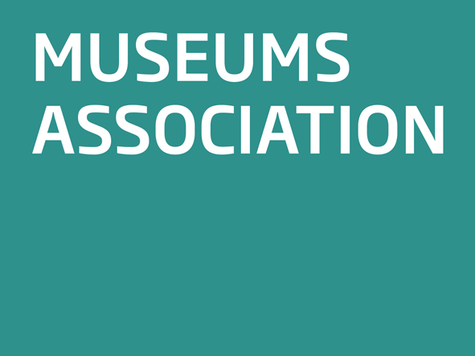

Museums Association

Creative Europe

Response to Consultation
March 2012

Background
The Museums Association (MA) is the only organisation that represents the full range of museums and galleries throughout the United Kingdom and people who work for them. The MA has over 6,000 institutional and individual members representing all types of museums from the largest nationals to small independents and everything in between. It is a membership organisation, a charity and company limited by guarantee and receives no regular public funding. The MA has an exceptional track record in setting strategic direction for museums and encouraging new thinking and improved practice. www.museumsassociation.org It is also a member of the Network of European Museum Organisations (NEMO) which represents museums throughout the Europe.

Introduction
The Museums Association (MA) welcomes the EU Commission’s proposal on the new framework programme for culture, Creative Europe. The current Culture programme is the only EU instrument exclusively dedicated to supporting arts and culture. Over the past ten years it has supported extensive cultural co-operation across borders and has contributed to the development of the cultural sector across Europe. Investing in such projects underpins the concept of societies that value arts and culture as factors that strengthen solidarity between communities and is particularly important in the context of uncertainty due to the financial crisis and to the delivery of the Europe 2020 objectives on inclusive growth.
Further Points
- The coming together of the previous Culture and Media programmes is understandable from the point of view of the Commission as it provides savings in administration but it is not clear what the benefits are for the respective sectors. It will inevitably mean a more superficial approach with Media predominant and the danger that Culture has to adapt to the rationale of Media.

- The Commission seeks to promote the concept of creativity with an emphasis on the economic impact of the ‘creative industries’ nurtured and prompted by culture. There is a danger that economic impact will be the only measure by which the programme will be measured. The role culture plays within nations and across Europe has impact in terms of education, communities, history, inspiration and wellbeing. To promote culture as simply an agent of economic growth is to underplay its role and undermine its existence.

- However, culture in general and museums in particular are key factors on nurturing creativity:

- through their collections inspiring people and creativity
- as one of the few places where creativity is displayed free of commercial restraint, where creative people can experiment and go beyond borders
- by being creative in the sense that they constantly seek new ways of exhibiting their collections and engaging local communities
- digital programmes encourage creativity in finding ways to interact with the collections

- It is understandable and welcome that the programme has to deliver against the Europe 2020 Strategy and that it should strive to make the sector more robust and resilient, acknowledging its role in job creation and growth. But there is little or no reference to culture’s pivotal role in driving tourism from within Europe and from other continents. In addition there seems little recognition of museums’ role as catalysts for urban regeneration and local economic development.

- One of the strong points of the current Culture programme is the support for European networks. It recognises the networks’ contribution to European co-operation and the exchange of knowledge and experience. NEMO is a good example. The proposed framework will end operational funding costs of networks. This threatens the good work of networks and the support they provide for the European Union in the context of policy making and dialogue with civil society. Most of the networks work without sufficient financial support; cutting funding for their operational costs will lead to a reduction of their work and many may fold. Funding for networks should continue.

- The MA welcomes the provision in the proposal relating to the opening of the Creative Europe programme to the European Neighbourhood countries on the basis of relevant agreements and urges the EU to conclude agreements on cultural co-operation with the European Neighbourhood countries as soon as possible.

- The facility to include and encourage small and medium size cultural institutions is welcome. The Culture programme has always been seen to be for larger institutions as smaller ones lacked the capacity and contacts to become involved. The majority of museums are small enterprises and genuinely community based and the Commission needs to find practical arrangements to enable them to take part in the programme.

For further information please contact Mark Taylor, Director, Museums Association: mark@museumsassociation.org; 0207 426 6950

